**Appendix 10: System design**

Several design decisions have been made during the analysis as these stages interfere. The purpose of the both processes is to gradually add details. Familiarity with the domain and the engineering process might lead to blurriness of transition between the stages. Therefore, some steps of the design stage might be omitted or might require a minor modification.

**Refining system operations**

If there are changes in the classes required these will be listed below each of the operations.

Use case 1

**contex** Line::areaActive(alert : Alert, line : Line, area : Area) : Boolean

**post:**

- - if there is an alert with the same lineCode as the line

- - and the same areaCode as area then

- - true will be returned

- - otherwise, false will be returned

Changes:

- new attribute in *Alert* class – *areaCode*

- new attribute in *Alert* class – *lineCode*

- removed attribute lineStatus from Alert class

**context** Shift::activateDowntime(stoppage : Stoppage, startTime : Time, stoppageID : Identity, description : String, area : Area, line : Line, alert : Alert): String

**pre:**

- - areaActive(alert : Alert, line : Line, area : Area) in line must have returned true

**post:**

- - a new Stoppage object, stoppage, will have been created (object creation) with attributes set to startTime, a newly created or reused stoppageID, and a newly created or reused description

- - stoppage will be linked to area

- - a new Alert object, alert, will have been created (object creation) with attributes set to area areaCode, line lineCode and message to string containing area attribute name,lineCode and the word down

- - alert will be linked to line

- - alert will be linked to area

- - line status attribute in line will change

- - a string indicating stoppage will have been returned

- - otherwise a string indicating failure will have been returned

**context** Operator::createStoppage(stoppageID : Identity, description : String, duration : Integer, startTime : Time, endTime : Time, occurrences: Integer, solution: String) : Stoppage

**context** MTL::createStoppage(stoppageID : Identity, description : String, duration : Integer, startTime : Time, endTime : Time, occurrences: Integer, solution: String) : Stoppage

**context** Area::createAlert(lineCode : String, areaCode : String, message : String) : Alert

Changes:

- new association between the Area and Alert classes

- attribute name ID in Stoppage class changed to stoppageID

Use case 2

**context** Operator::contactTeamLeader(request : Request, type : Type, message : String, areaCode : String, lineCode : String, mtl : MTL): Boolean

**pre:**

- - areaActive(alert : Alert, line : Line, area : Area) in line must have returned false

**post:**

- - a new Request object, request, will have been created (object creation) with attributes set to type, message, areaCode and lineCode

- - request will be linked to operator

- - request will be linked to MTL

- - request will be linked to area

- - request will be linked to line

- - true will be returned

- - otherwise, false will be returned

Changes:

- lineCode attribute added to the Request class

**context** Shift::informTeamLeader(request : Request, stoppage : Stoppage, type : Type, message : String, areaCode : String, lineCode : String): Boolean

**pre:**

- - areaActive(alert : Alert, line : Line, area : Area) in line must have returned false

- - stoppage duration attribute is more or equal to 15 minutes

**post:**

- - a new Request object, request, will have been created (object creation) with attributes set to type, message, areaCode and lineCode

- - request will be linked to MTL

- - request will be linked to area

- - request will be linked to line

- - true will be returned

- - otherwise, false will be returned

**context** Operator::createRequest(type : Type, message : String, areaCode : String, lineCode : String) : Request

**context** Request::create(type : Type, message : String, areaCode : String, lineCode : String) : Request

Use case 3

**context** ETL::confirmRequest(request : Request) : Boolean

**context** Shift::requestRepair(request : Request, type : Type, message : String, areaCode : String, lineCode : String, etl : ETL, repair : Repair, mtl : MTL, operator : Operator) : Boolean

**pre:**

- - areaActive(lineCode : String, lineStatus : String) in line returned false

**post:**

- - a new Request object, request, will have been created (object creation) with attributes set to type, message, areaCode, lineCode

- - request will be linked to operator or

- - request will be linked to mtl

- - request will be linked to etl

- - if confirmRequest(request : Request) in etl returned true then

- - a new Repair object, repair, will have been created (object creation) with attributes set to areaCode, lineCode,

- - repair status attribute will change

- - area will be linked to repair

- - line will be linked to repair

- - true will be returned

- - otherwise, false will be returned

**context** ETL::createRepair(areaCode, lineCode) : Repair

Changes:

- new association between *Line* and *Repair*

- removed attribute status from the *Repair* class as it is known if it is active due to object creation otherwise it won’t exist

Use case 4

**context** MTL::contactManager(request : Request, stoppage : Stoppage, type : Type, message : String, areaCode : String, lineCode : String, mtl : MTL): Boolean

**pre:**

- - areaActive(alert : Alert, line : Line, area : Area) in line must have returned false

- - stoppage duration attribute is more or equal to 30 minutes

**post:**

- - a new Request object, request, will have been created (object creation) with attributes set to type, message, areaCode and lineCode

- - request will be linked to MTL

- - request will be linked to SOM

- - request will be linked to area

- - request will be linked to line

- - true will be returned

- - otherwise, false will be returned

**context** MTL::createRequest(type : Type, message : String, areaCode : String, lineCode : String) : Request

**context** SOM::createRequest(type : Type, message : String, areaCode : String, lineCode : String) : Request

Use case 5

No changes required.

Use case 6

**context** MTL::updatePerformance(lineCode : Line, performance : Performance, score : Integer) : Boolean

**pre:**

- - performance must exist

- - performance is linked to mtl

- - lineCode attribute of performance must be the same as the lineCode argument

**post:**

- - performance hourlyScore will be set to score

- - performance hourlyPerformance will be changed

- - performance cumulativePerformance will be changed

- - true will be returned

- - otherwise, false will be returned

**context** Stoppage::updateEfficiency(efficiency : Efficiency, stoppages : Collection, lineCode : String, time : Time) : Boolean

**pre:**

- - efficiency must exist

- - line code for stoppages equals lineCode

**post:**

- - efficiency issues will be set to three strings containing description of three stoppages with the highest duration

- - efficiency hourlyStoppage will be set to total duration of stoppages within 60 minutes prior to time

- - efficiency totalStoppage will be updated adding efficiency hourlyStoppage

- - true will be returned

- - otherwise, false will be returned

**context** MTL::checkPerformance(performance : Performance, line : String, efficiency : Efficiency) : Collection

**pre:**

- - performance lineCode equals line

- - efficiency lineCode equals line

**post:**

- - performance hourlyPerformance will be added to Collection

- - performance cumulativePerformance will be added to Collection

- - efficiency hourlyStoppage will be added to Collection

- - efficiency totalStoppage will be added to Collection

- - Collection will be returned

Use case 7

**context** Shift::makeDailyReport(mtl : MTL, performance : Performance, line : Line, efficiency : Efficiency, lineID : String, date : Date) : Collection

**pre:**

- - mtl is linked to performance

- - mtl is linked to efficiency

- - performance is linked to Line

- - efficiency is linked to Line

**post:**

- - a new DailyReport object, report, will have been created

- - report will be linked to performance

- - report cumulativePerformance will be set to performance attribute cumulativePerformance

- - report cumulativePerformance will be added to Collection

- - report will be linked to efficiency

- - report cumulativeEfficiency will be set to efficiency attribute totalStoppage

- - report cumulativeEfficiency will be added to Collection

- - report lineCode will be equal to lineID

- - report will be linked to mtl

- - Collection will be returned

Use case 10

**context** SOM::isReport(aDate : Date, lineID : String) : Boolean

**pre:**

- - DailyReport object with date equal to aDate exist

- - DailyReport object’s lineCode equals lineID

**context** Shift::reviewPerformance(som : SOM, lineID : String, aDate : Date, report : DailyReport) : DailyReport

**pre:**

- - isReport(aDate : Date, lineID : String) must have returned true

**post:**

- - som will be linked to report

- - report will be linked to line

- - DailyReport object will be returned

**Design model**

The figures below show (in chunks) the structural design model for the Downtime Management System as the whole model would be unreadable. It consists all the changes made during the design stage. It is very difficult to capture all inconsistencies however the greatest effort has been put into making it consistent.

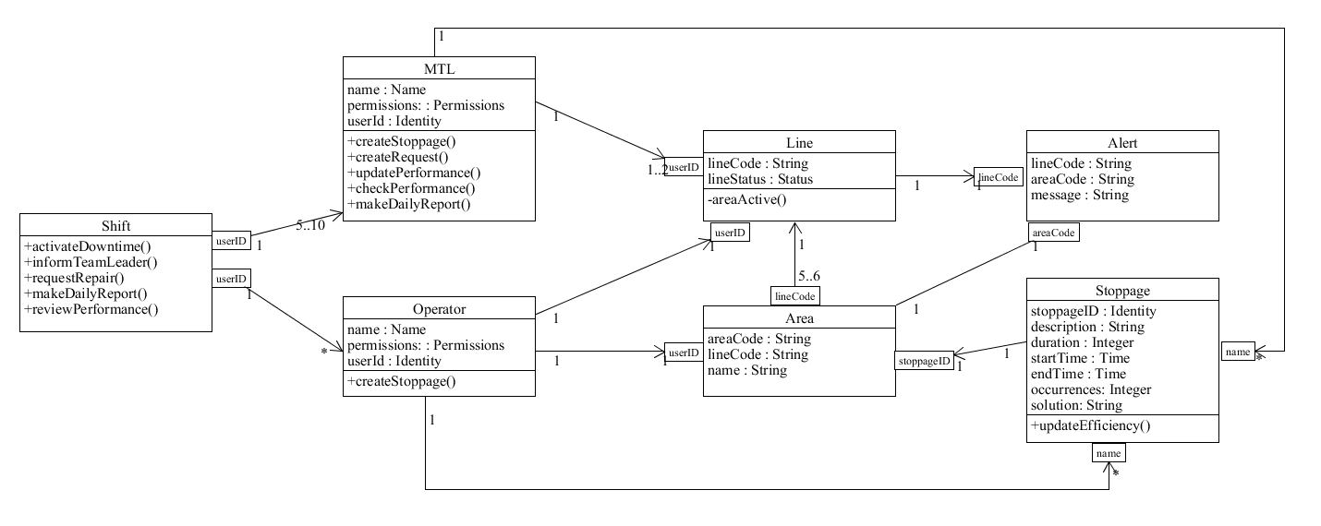

**Figure 1** Part of the structural design model for Downtime Management System.

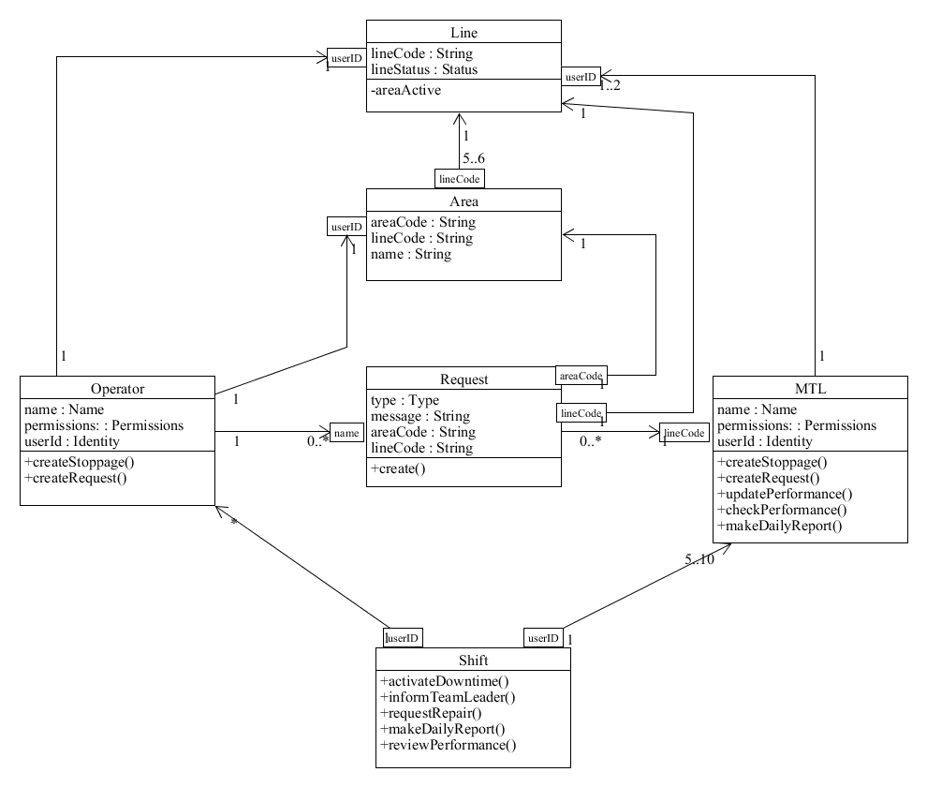

**Figure 2** Part of the structural design model for Downtime Management System.

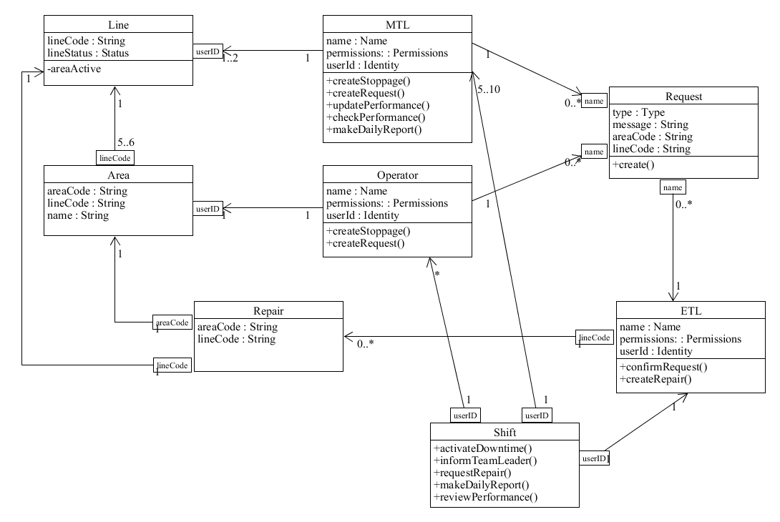

**Figure 3** Part of the structural design model for Downtime Management System.

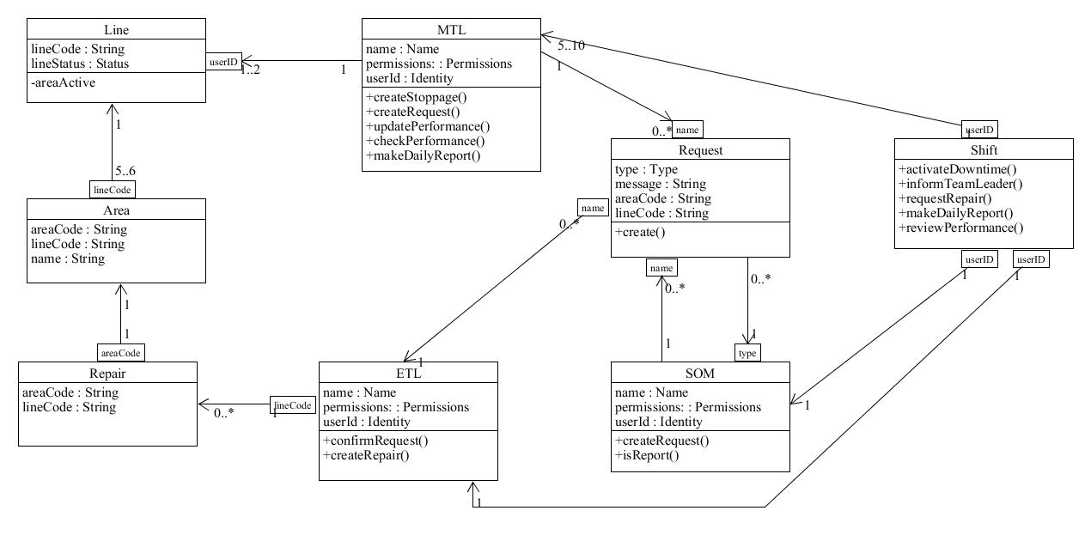

**Figure 4** Part of the structural design model for Downtime Management System.

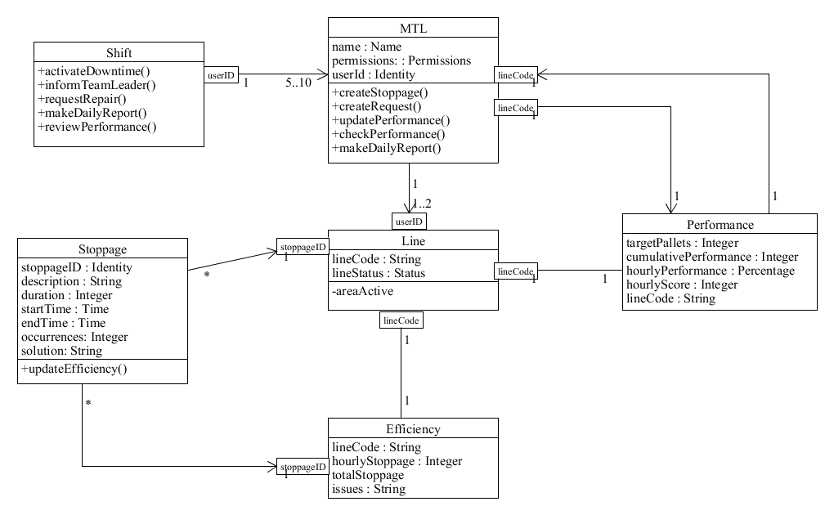

**Figure 5** Part of the structural design model for Downtime Management System.

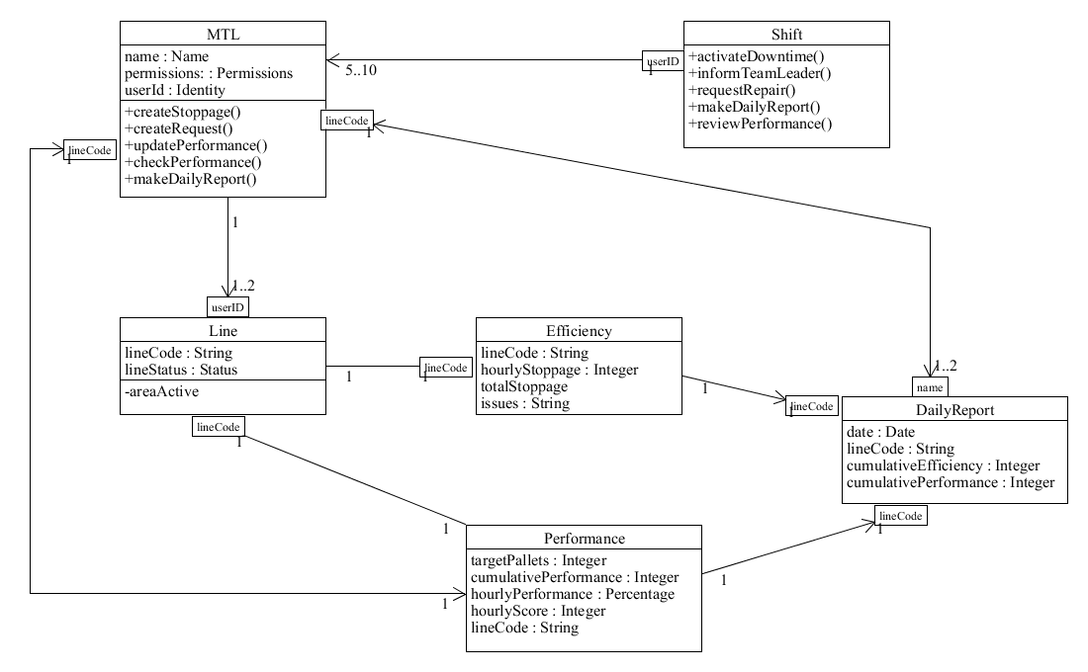

**Figure 6** Part of the structural design model for Downtime Management System.

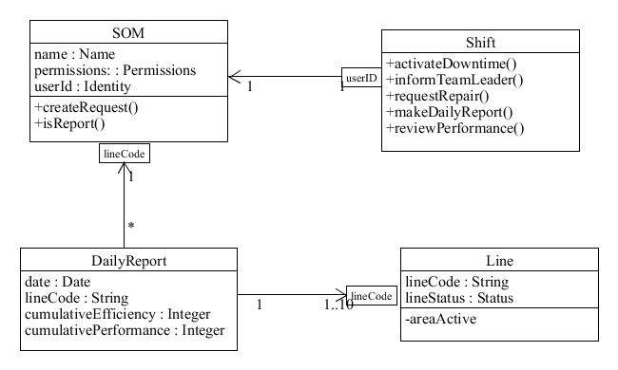

**Figure 7** Part of the structural design model for Downtime Management System.